School Technology Plan Template

MISSION/VISION STATEMENT
A mission statement defines your school’s goals and objectives and its approach to reach those objectives. A vision statement describes the desired future position of the school.
Questions to consider:
- Does your school/district already have a mission or vision statement?
- Does your district have a strategic plan? How does this connect to it?
- What motivates your staff to embrace change?

TECHNOLOGY PLAN COMMITTEE MEMBERS
The following people are acknowledged for their time, thoughtful contributions, and commitment to this learning.
Questions to consider:
- When/where will these meetings be held so that its available to all? (e.g., before school, after school, staff meetings, virtual/in person, etc.)
- How often will these meetings be held? How much additional effort is expected from staff?
- Is it mandatory or optional for staff?
- How to provide a space for safe conversation where people feel heard and valued?
- Have you included all stakeholders (e.g., teachers, educational assistants, students, parents, school trustee, district administrator, community members, etc.)?
- How is this information being communicated/shared out?

GUIDING PRINCIPLES – International Society for Technology in Education (ISTE) Standards
These standards are a road map to helping students become empowered learners. They will deepen educators’ practices, promote collaboration, and challenge them to re-think traditional approaches.
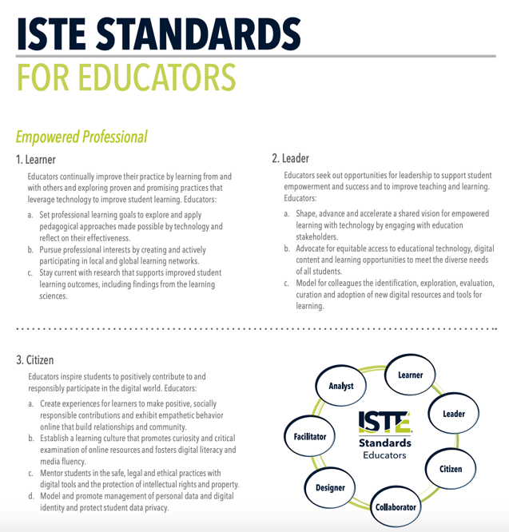  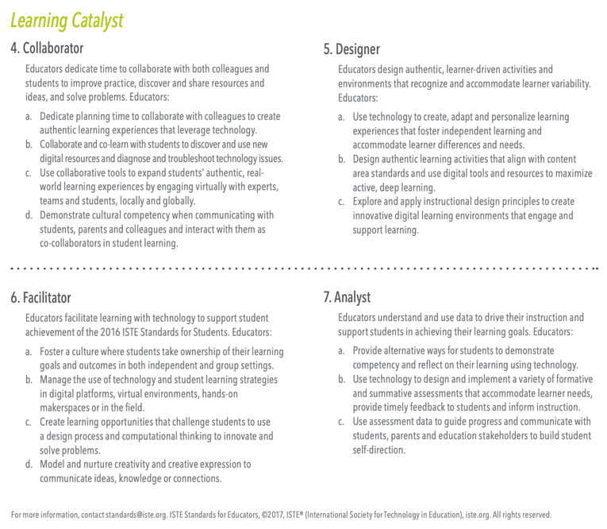 | Questions to consider:  - How can this be used as a guide?  - Where are you seeing examples of this already?  - What are you trying to accomplish?  - If working in BC – can link to BC Digital Literacy Framework?

NEEDS ASSESSMENT AND ANALYSIS
Overall feeling from teachers and other stakeholders about educational technology in the school currently.
Samples:  The Organizational Climate Questionnaire (OCDQ-RE)  Denison Organizational Culture Survey (sample report)  Staff Technology Survey by Emily Miller (Google Forms)  Family & Community Members Technology Survey by Emily Miller (Google Forms) | Questions to consider:  - Which different stakeholder groups need to be targeted with a need’s assessment?  - What is the best way to do this? (e.g., survey, interview, informal and formal observations, focus groups, etc.)  - What does the data show?
DISTRICT AND SCHOOL INFRASTRUCTURE
There are many things that need to be in place in order for a school to run a successful technology program. Outline your district and school’s infrastructure.
Questions to consider:
- What is the internet bandwidth in your building(s)?
- What is your device to teacher and device to student ratio?
- What district digital resources do you have access to? Are there guidelines?
- What is the district and school protocol for device maintenance and upgrades?
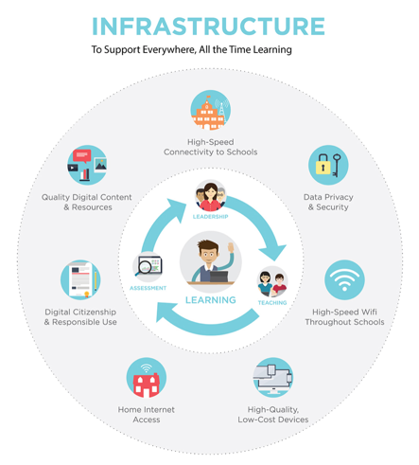
- What is the structure of support within the school/district?
- Is there a student support team?
https://tech.ed.gov/netp/graphics/

PLAN AND PROCEDURE
In the tables below, list your school goals and specific information about how your school can achieve those goals

Goal #1: | Timeline: | Questions to consider:  - How could this connect to the District Strategic Plan?  - How do you address perceptions of ease of use and usefulness when it comes to new technology?  - How to encourage innovation?  - What are the expectations of teachers in their use of technology?  - How to make the learning an authentic, hands-on, and a worthwhile experience?  - How to develop opportunities for capacity building for staff – small and large group?  - How to plan for a variety of learning experiences – formal and informal?  - Who will be providing those learning experiences? (e.g. district experts, colleagues, teacher in another school, observations, co-teaching, mentor, etc.)  - Who is going to be collecting the evidence?  - How do you track progress?  - How often do you build in reflective action to review the goals and progress?  - Is the timeline realistic?
Evidence: | Resources Needed:
Outcome(s):

Goal #2: | Timeline: | Questions to consider:  - How could this connect to the District Strategic Plan?  - How do you address perceptions of ease of use and usefulness when it comes to new technology?  - How to encourage innovation?  - What are the expectations of teachers in their use of technology?  - How to make the learning an authentic, hands-on, and a worthwhile experience?  - How to develop opportunities for capacity building for staff – small and large group?  - How to plan for a variety of learning experiences – formal and informal?  - Who will be providing those learning experiences? (e.g. district experts, colleagues, teacher in another school, observations, co-teaching, mentor, etc.)  - Who is going to be collecting the evidence?  - How do you track progress?  - How often do you build in reflective action to review the goals and progress?  - Is the timeline realistic?
Evidence: | Resources Needed:
Outcome(s):

Goal #3: | Timeline: | Questions to consider:  - How could this connect to the District Strategic Plan?  - How do you address perceptions of ease of use and usefulness when it comes to new technology?  - How to encourage innovation?  - What are the expectations of teachers in their use of technology?  - How to make the learning an authentic, hands-on, and a worthwhile experience?  - How to develop opportunities for capacity building for staff – small and large group?  - How to plan for a variety of learning experiences – formal and informal?  - Who will be providing those learning experiences? (e.g. district experts, colleagues, teacher in another school, observations, co-teaching, mentor, etc.)  - Who is going to be collecting the evidence?  - How do you track progress?  - How often do you build in reflective action to review the goals and progress?  - Is the timeline realistic?
Evidence: | Resources Needed:
Outcome(s):

COMMUNITY RESOURCES AND SUPPORT
There are many ways to get technical and financial aid to support the success of a technology plan. Do some research into how the surrounding community can help support your specific school goals.
Questions to consider:
- What is the process for requesting funding from the School District?
- How can your PAC help support your technology plan?
- Are there any businesses in your community…
  - that offer technology grants?
  - that are donating old technology?
  - That can collect donations to support a technology fund?

If needed, use this Technology Grant Application Template to request district or community funding support. Please make a copy and customize as needed.

